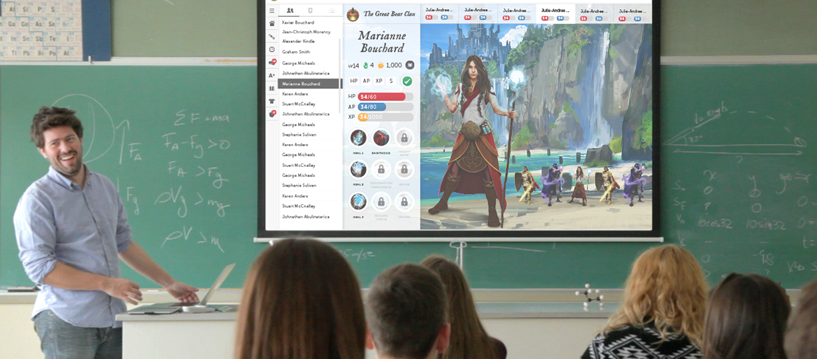
INTRODUCING PARENTS TO CLASSCRAFT
By integrating Classcraft into your curriculum, you’ve made an important change in the lives of your students. As teachers, you may want to help parents understand how Classcraft is helping their children to succeed.
Some teachers may consider inviting parents to an evening meeting where they can learn all about how Classcraft works. Feel free to print out our accompanying “Parent Handout” PDF on our Support page, which details the basics of the game, to distribute to parents as they arrive. Below are a few additional tips for making the teacher-parent night a success:
- Play the Classcraft video, found at the top of our main website at www.classcraft.com. This will provide a nice overview of the game.
- Explain to parents why you chose to use Classcraft. This will help them to understand the positive meaning it has for you as an educator.
- Walk parents through a normal class day. Do you introduce a random event at the beginning of class to get students’ attention? What kinds of behaviors do you reward or punish in class? How do students work together as teams to help each other improve?
- Tell a story. Talk about something silly and fun that happened in the game and how it benefited the learning experience.
- If time permits, discuss quiz and test scores with each child’s parents, or talk to them one-on-one about how you’ve seen their child’s participation, motivation, and attitude in class change because of Classcraft.
- Allow parents to ask questions. If you don’t know the answer, tell them you’ll follow up soon. Then send an email to info@classcraft.com.*
*Parents should always address questions to the gamemaster (teacher) rather than to Classcraft.

